**Breadboarding Guidelines and Lab Component**

**Usage**

**3rd Laboratory Report for ECE 383**

**Microcomputers**

**Submitted by**

**Shomari Thomas**

**11672867**

**Yichen Huang**

**11906882**

**The University of Alabama**

**Tuscaloosa, Alabama 35487**

**February 5, 2020**

**Abstract**

This lab was designed to introduce the concept of breadboarding, and how the lab components would be used throughout the semester. In the lab, we learned how to design basic breadboard circuits using the lab components for this semester. The first task was to calculate and test the properties of three components in the lab, two resistors and one capacitor. The resistors resistance was measured, the capacitors capacitance was measured, and then these values were compared to the calculated values. The second task was to create a voltage divider on the breadboard using two resistors, and then calculate and measure the voltage output of the circuit. The third task was to calculate and measure current across the previously created circuit. The fourth and final task was creating a digital clock circuit using resistors, capacitors, and a 555 timer chip. We also learned how to use the oscilloscope with this task.

**Introduction**

The objective of this lab is to become more familiar with breadboarding, the DMM(Digital Multimeter), the power supply, the oscilloscope, and the lab components for this semester. Task one has us placing three components into the breadboard, two resistors and one capacitor. First we calculate the expected resistance of the 2.2kΩ resistor and the 910Ω resistor, and the capacitance of the 1.0µF Capacitor. Then, it has us measuring the resistance of the 2.2kΩ resistor and the 910Ω resistor, and the capacitance of the 1.0µF capacitor by using the DMM. Task two has us creating a basic voltage divider on the breadboard, and calculating the expected voltage . Using the resistors from task one, we create a basic circuit, and then use the DMM to measure the voltage. Task three has us first calculate the expected current of the circuit from task two, and then take the circuit and replace some wiring to allow the DMM to be used to measure the current of the circuit. Task four has us create a new clock circuit using a 555 timer chip, a 10kΩ resistor, a 100kΩ resistor, and a 1µF capacitor. The two resistors had their resistance measured, and the capacitor had its capacitance measured, and then the circuit was assembled based on the circuit diagram in the lab handout. Following the steps in the lab handout, we recorded the cycle time, on time, duty factor, and frequency.

**Procedure/Results**

Task one has us measure the basic resistances of two resistors and the capacitance of one capacitor. Then it has us placing three components into the breadboard, two resistors and one capacitor. First, we calculate the expected resistance of the 2.2kΩ resistor and the 910Ω resistor, and the capacitance of the 1.0µF Capacitor. Then, it has us measuring the resistance of the 2.2kΩ resistor and the 910Ω resistor, and the capacitance of the 1.0µF capacitor by using the DMM.

Task two has us creating a basic voltage divider on the breadboard and calculating the expected voltage. Using the resistors from task one, we create a basic circuit, and then use the DMM to measure the voltage.

Task three has us first calculate the expected current of the circuit from task two, and then take the circuit and replace some wiring to allow the DMM to be used to measure the current of the circuit.

Task four has us create a new clock circuit using a 555-timer chip, a 10kΩ resistor, a 100kΩ resistor, and a 1µF capacitor. The two resistors had their resistance measured, and the capacitor had its capacitance measured, and then the circuit was assembled based on the circuit diagram in the lab handout. Following the steps in the lab handout, we recorded the cycle time, on time, duty factor, and frequency.

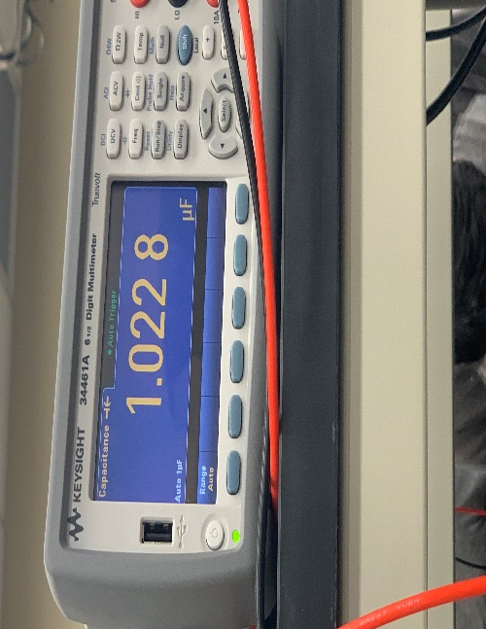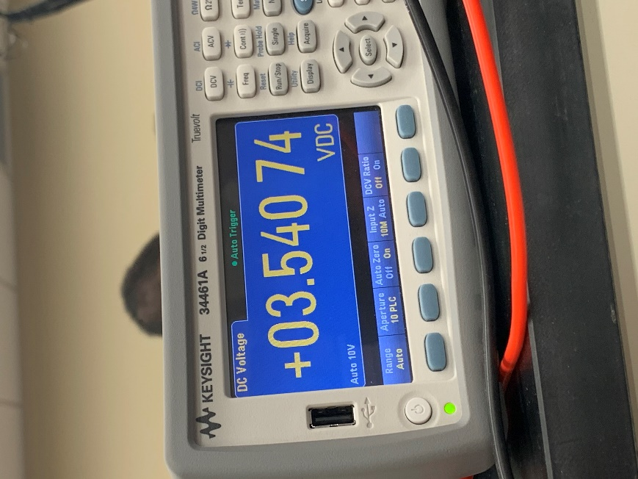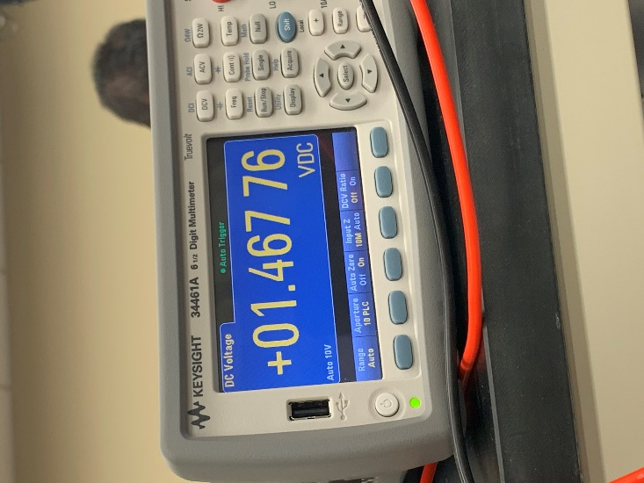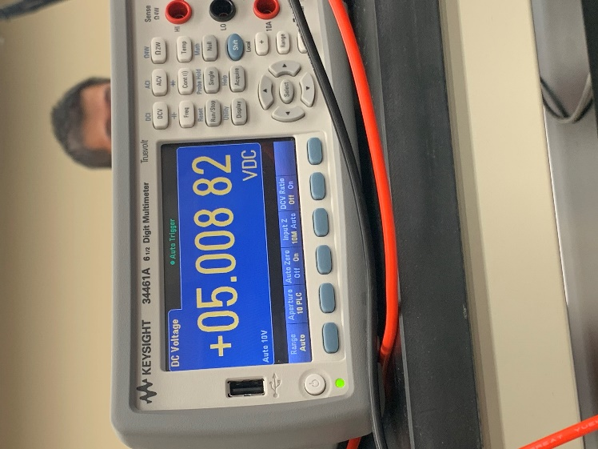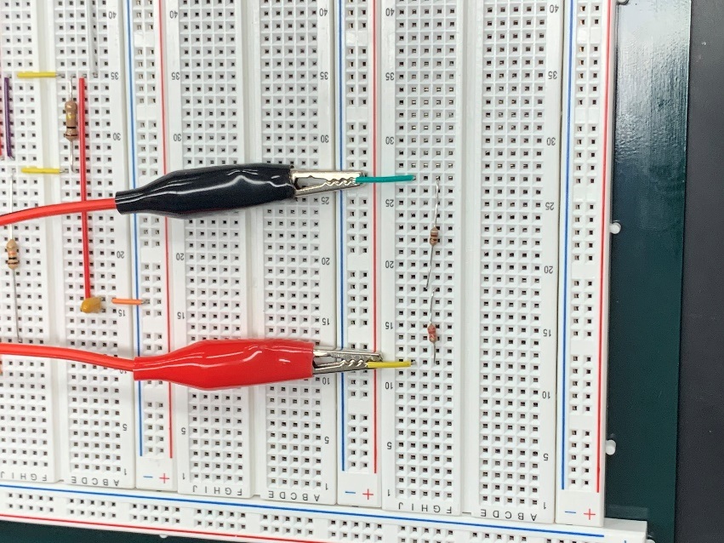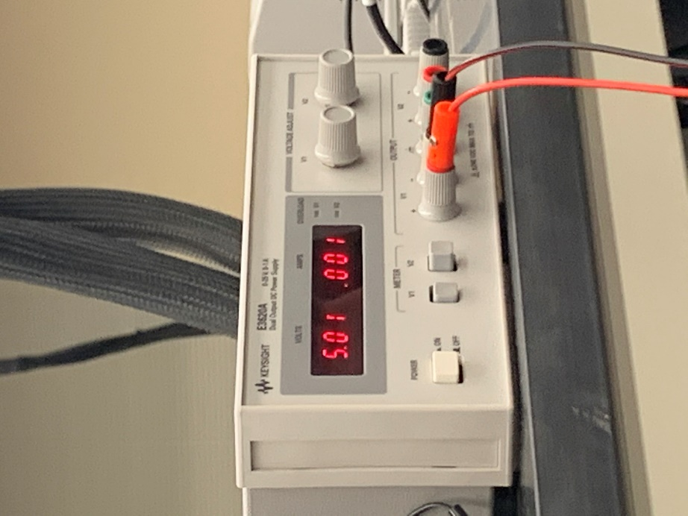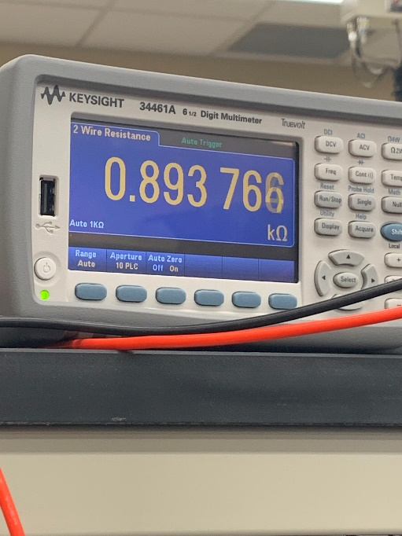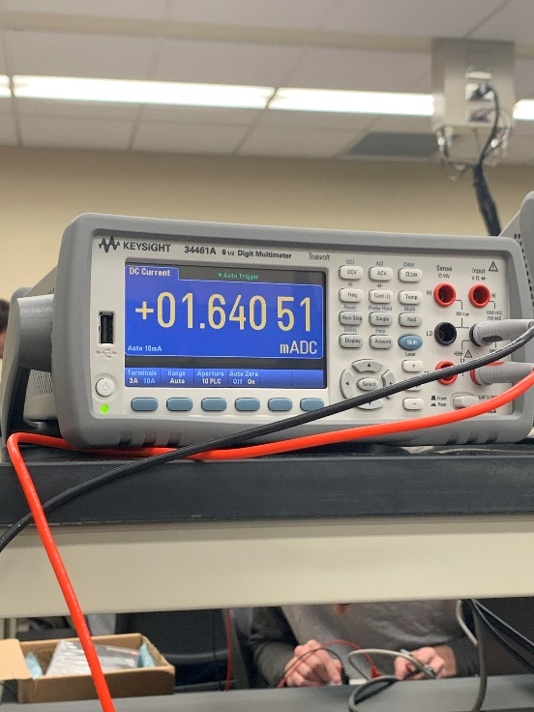

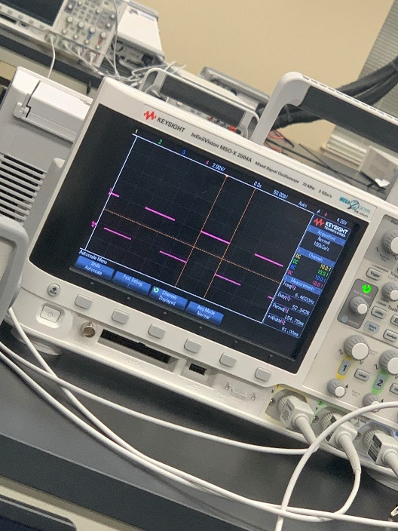

**Conclusion**

This second lab was a learning experience for breadboarding and the various tools and lab components used this semester. We were taught how to create basic circuits in the breadboard, and learned how to use the DMM, the Oscilloscope, and the Power Supply. We now know how to properly create basic breadboard circuits, and how to properly use the various parts and tools available in the lab. Overall, we now have a better understanding of breadboard circuits and the various tools and components at our disposal.